**Disaster Animation Exercise**

**Student Name: Student Id:**

**Date:**

Please use the screenshots ONLY as a reference. The written instructions have to be followed AS written.

50% of the assignment will be graded on the documentation and 50% of the assignment would be graded based on the project created in Tableau

As a part of this exercise you need to submit following documents:

* This exercise document with your answers
* Your Tableau file

### Objective:

The objective of this exercise is to find missing geocodes of disaster locations and create an animated data visualization displaying all the disasters on a map and its impact on refinery locations

**Part 1: Find missing Geocodes**

**Step 1: Download dataset ‘Excel-1 Natural Disasters’ from ELearning**

* Dataset related to natural disasters is attached in ELearning, download the ‘Excel-1 Natural Disasters.xlsx’ file
* Read the ‘Instruction’ sheet of downloaded excel and make changes in the ‘Natural Disasters’ sheet as per given instructions

Note: You need to go back to your Exercise 5- Small multiples in Tableau to find top 4 disasters for your refinery and assign intensity values (Refer to Excel Instruction page for details)

**Step 2: Open Tableau and connect to a Data Source (upload dataset)**

* On opening Tableau below screen will appear, click on ‘Excel’ option under ‘Connect’ and upload the excel file that you have downloaded from ELearning

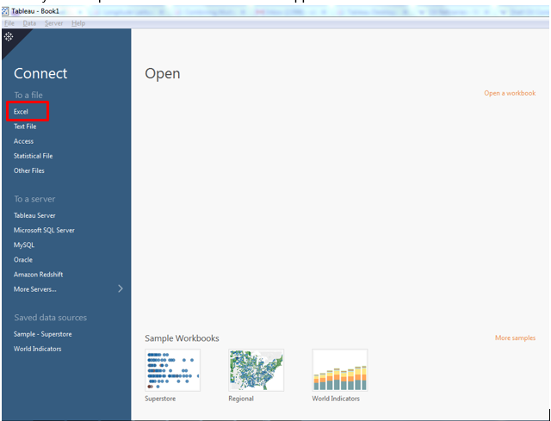

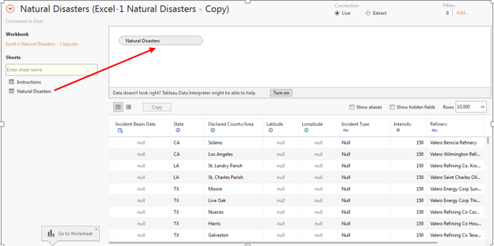

* Double click on ‘Natural Disasters’ sheet and once data is uploaded and rename it to ‘Disaster Animation’

**Step 3: Visualize natural disasters on map**

* To display all the disasters on the map double click on ‘Latitude’ and ‘Longitude’ measures field one by one, on completing this step your map will look like:

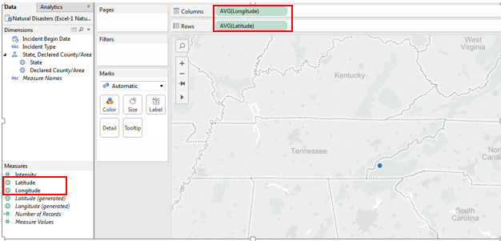

* **Reason of getting single dot on the map**: Tableau by default aggregates the measure fields hence it has aggregated (averaged) all the latitudes and all longitudes because of which you are seeing only one location on the map
* To see all the locations on the map we have to disaggregate latitude and longitude and to do so go to Analysis menu option and uncheck ‘Aggregate Measures’:

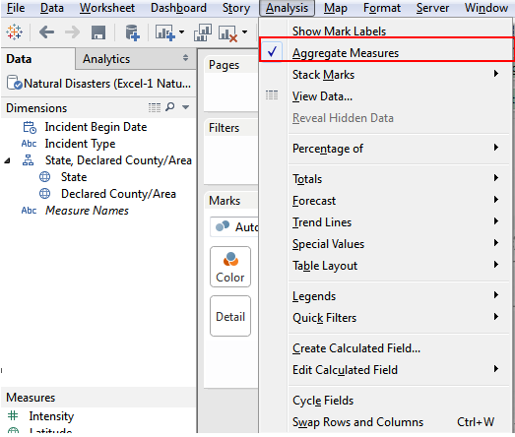

**Question:**

1. **Provide the screenshot of your workbook:**

**Answer**

**Step 4: Encode Map Data**

* Drag ‘Incident Type’ field to color card
* Drag and drop ‘State’ and ‘Declared County/Area’’ fields below ‘Incident Type’ (check screen shot)

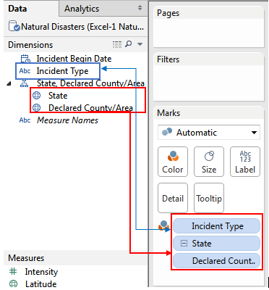

**Question:**

1. **Provide the screenshot of your Tableau sheet:**

**Answer**

**Step 5: Find Counties, States with missing geocodes**

* Check the right bottom corner of your map, there must be a label showing null values

**Note**: You may get different number based on your data file and Tableau version

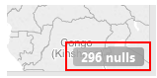

* Above label shows there are 296 geolocations that are missing
* On clicking the label you will get a pop-up, select ‘Filter Data’ in the pop-up, once you click on the Filter Data you will observe that Tableau has created a filter on ‘Longitude’ field which is filtering all the null values of latitude and longitude. To confirm this, click on the arrow of ‘Longitude’ field and select filter:

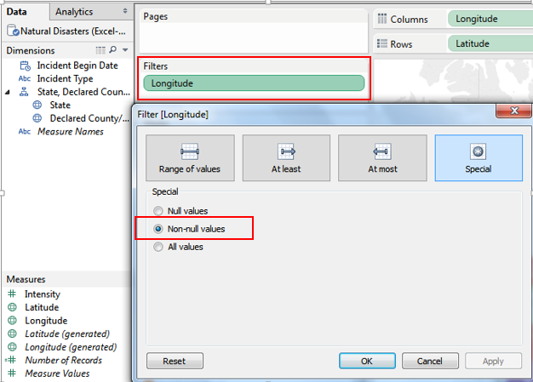

* Since we are interested in knowing what all geocodes are missing, we will select ‘Null Values’ in above filter and once we apply this filter all the data will disappear from your map

**Question:**

1. **Why did all the data disappear from the map?**

**Answer**

* To get States and Counties for which geocodes are missing, just right click on the map and select ‘View Data’

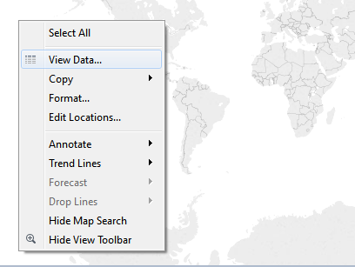

* On selecting ‘View Data’ a pop-up will appear which will show all the data having null latitude and longitude (geocodes), click on ‘Export All’ button and save the csv file

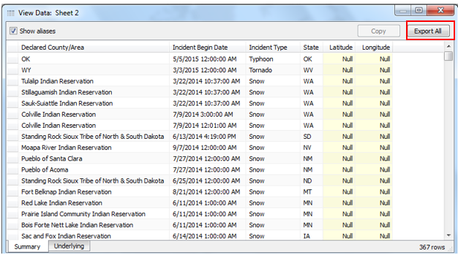

Step 6: Cleanse Data for Geocoding

* In this step we will find the geocodes of all States and Counties that are missing in our dataset

One of the reason why Tableau could not find geocodes for some of the counties and states because data is not cleansed, just scan through the data in excel file and you will find many counties do not have appropriate name, they have string concatenated with their name which is not useful in this context.

Review your missing geocode data and answer the following questions:

**Questions:**

1. There are some counties which have ‘PMSA’ string concatenated to their name, what does PMSA mean? **Hint**: use internet/Wiki to find the answer

**Answer**

1. There are some counties which have ‘MSA’ string concatenated to their name, what does MSA mean? **Hint**: use internet/Wiki to find the answer

**Answer**

1. There are quite a few counties which have a common string concatenated to their name (apart from PMSA and MSA), what is that string and what does it mean?

**Answer**

To cleanse the data we need to format the county names so that these counties can be geocoded, below hints will help you in cleansing the data:

**General Tip**: Use Filter and Find-Replace functionality of excel to expedite cleansing process and keep saving file after every step

* Open the missing geocodes csv file that you downloaded from Tableau in step-5 from

* To find geocodes we only need ‘Declared County/Area’ column and ‘State’ column hence delete other columns from the csv file
* Remove duplicate records of county and state combination, go to Data tab and chose ‘Remove Duplicates’ option and chose fields State and Declared County/Area
* Find those counties which have string ‘PMSA’ in their name, you need to cleanse these cells in such a way that they have only county name, for example one of the cell in the excel which has value:

‘Washington Countyin PMSA 5520,6480’, you need to remove all the unnecessary string from this cell and turn it into ‘Washington County’

* Find those counties which have ‘MSA’ , you need to cleanse these cells in such a way so that they have only county name, example:

‘York Countyin MSA 6400,6450’ -> ‘York County’

* Find those counties which have string ‘Indian Reservation’, you need to cleanse these cells in such a way so that they don’t have Indian reservation in their name, for example:

Moapa River Indian Reservation -> Moapa River

* After making above changes, save and close the file

**Step 7**: **Download ArcMap**

To fine missing geocodes we will use ArcMap tool provided by ARCGIS

* Before downloading ArcMap please check your system compatibility

<http://cyri.systemrequirementslab.com/client/standard/?apikey=50f41142-39b0-4061-97c2-ba7b7fe43d0e&refid=1186&item=10913>

* Create an ESRI account

<http://www.arcgis.com/features/free-trial.html?origin=arcgis>

* Activate the account (using link sent to your email id) and create username and password
* After activating your account, go to this URL and sign in with your credentials:

<https://www.arcgis.com/home/signin.html>

* Then click on your account name and select Trial Downloads.

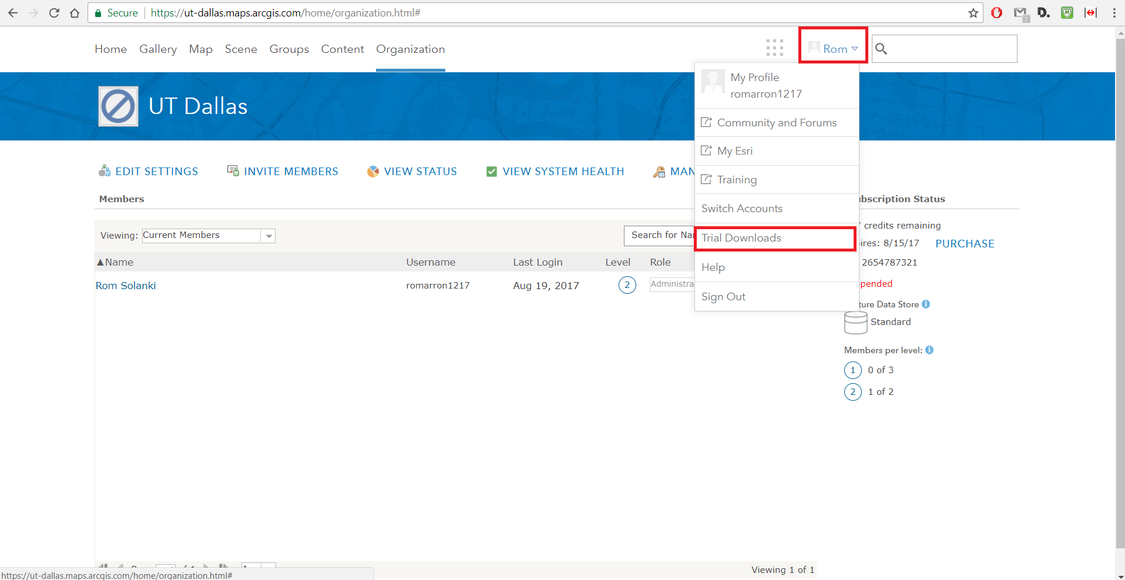

* Then click on the Download button under “ArcGIS Pro with these extensions” as indicated in screenshot below.

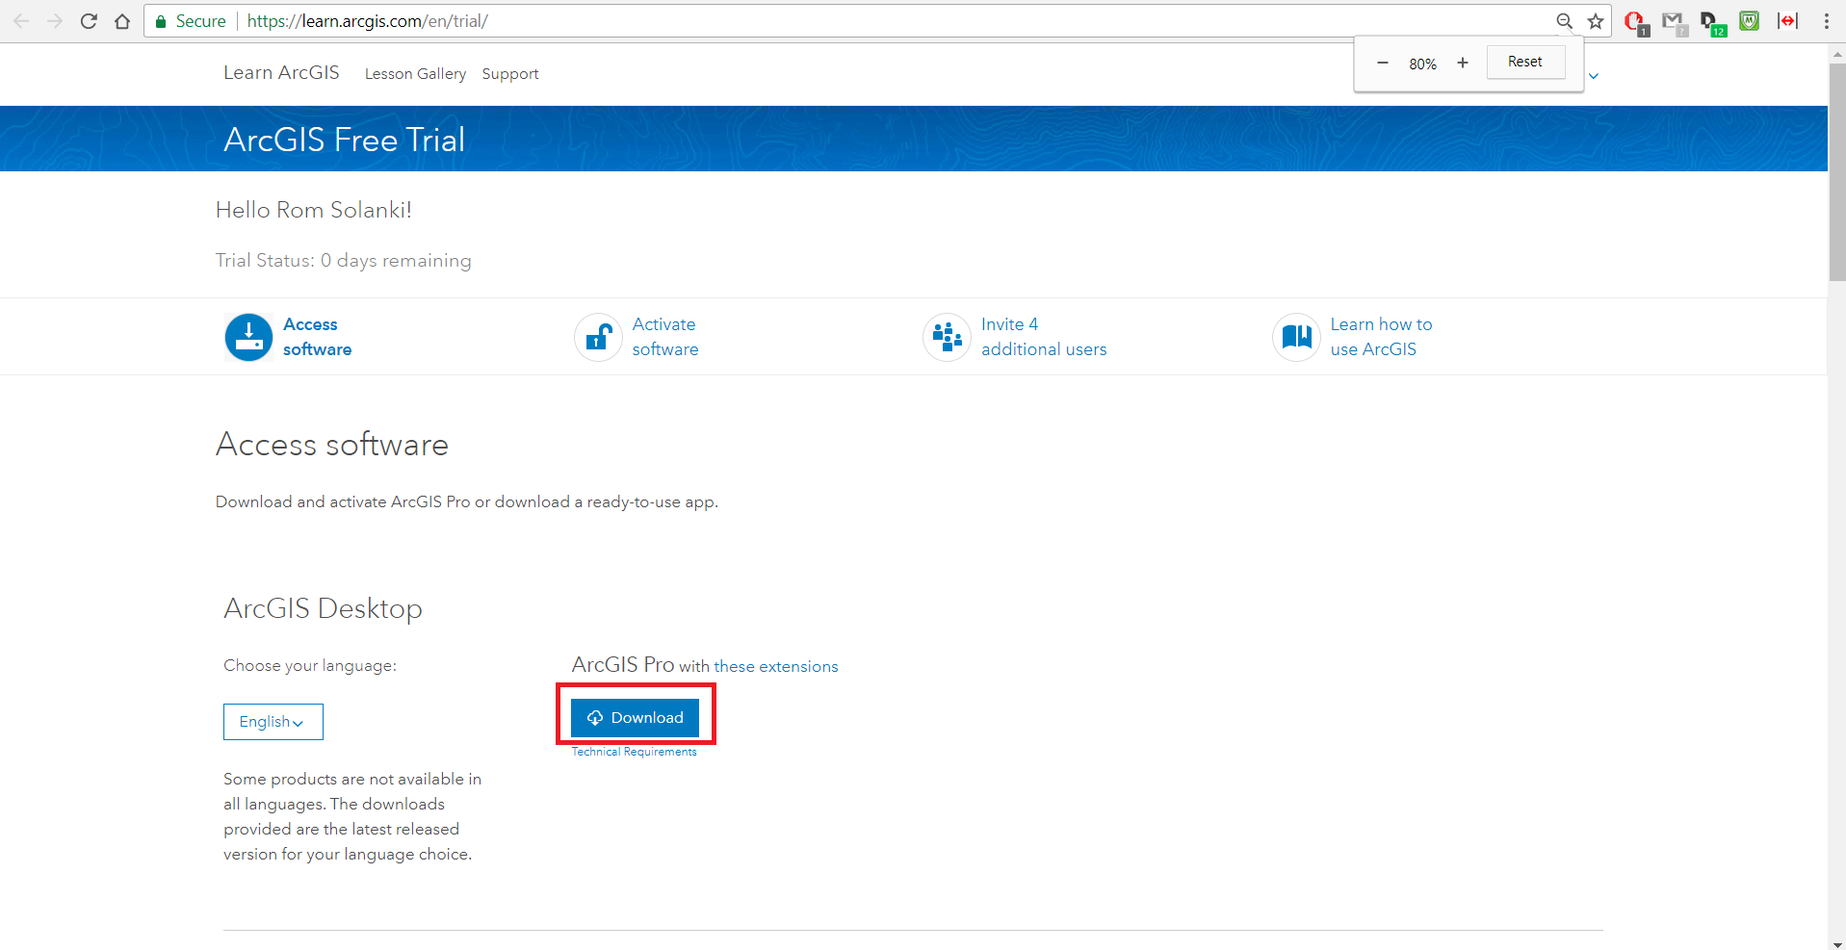

* After downloading the installer, double click on it and it will bring the following setup screen.

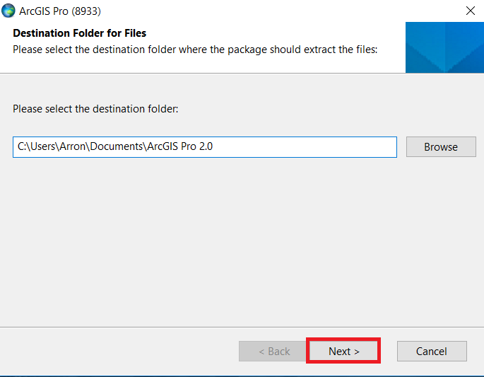

Click on next. The extraction process will start. Once it is completed, click on close.

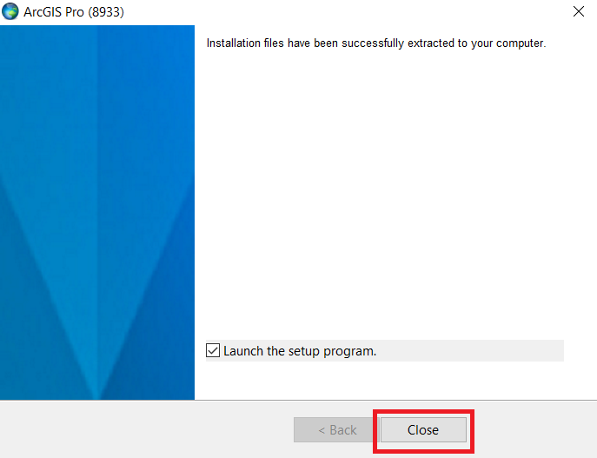

The installer will start.

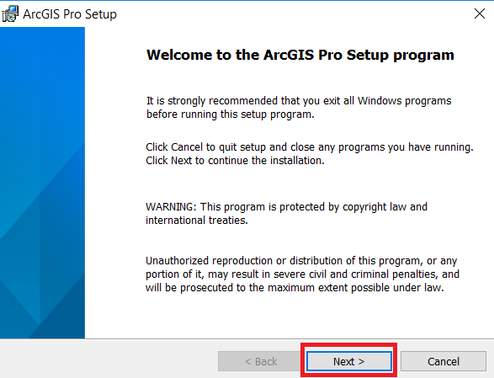

Click on Next.

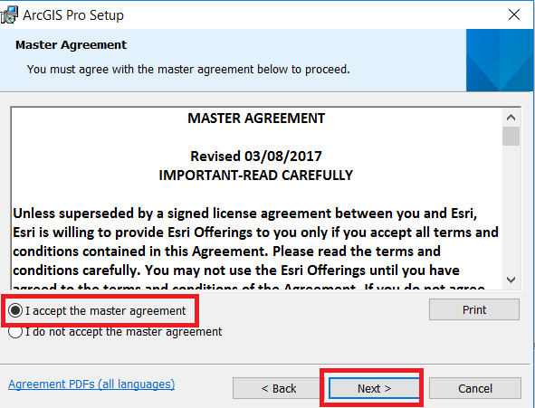

Then accept the license agreement

click on Next -> Click on “Anyone who uses this computer (All users)” and again click on Next -> Next -> Install.

Once the installation is complete click on Finish.

Go to this URL again and sign in with your credentials:

<https://www.arcgis.com/home/signin.html>

Fill up Organization Short Name as : <firstName>-UTDallas

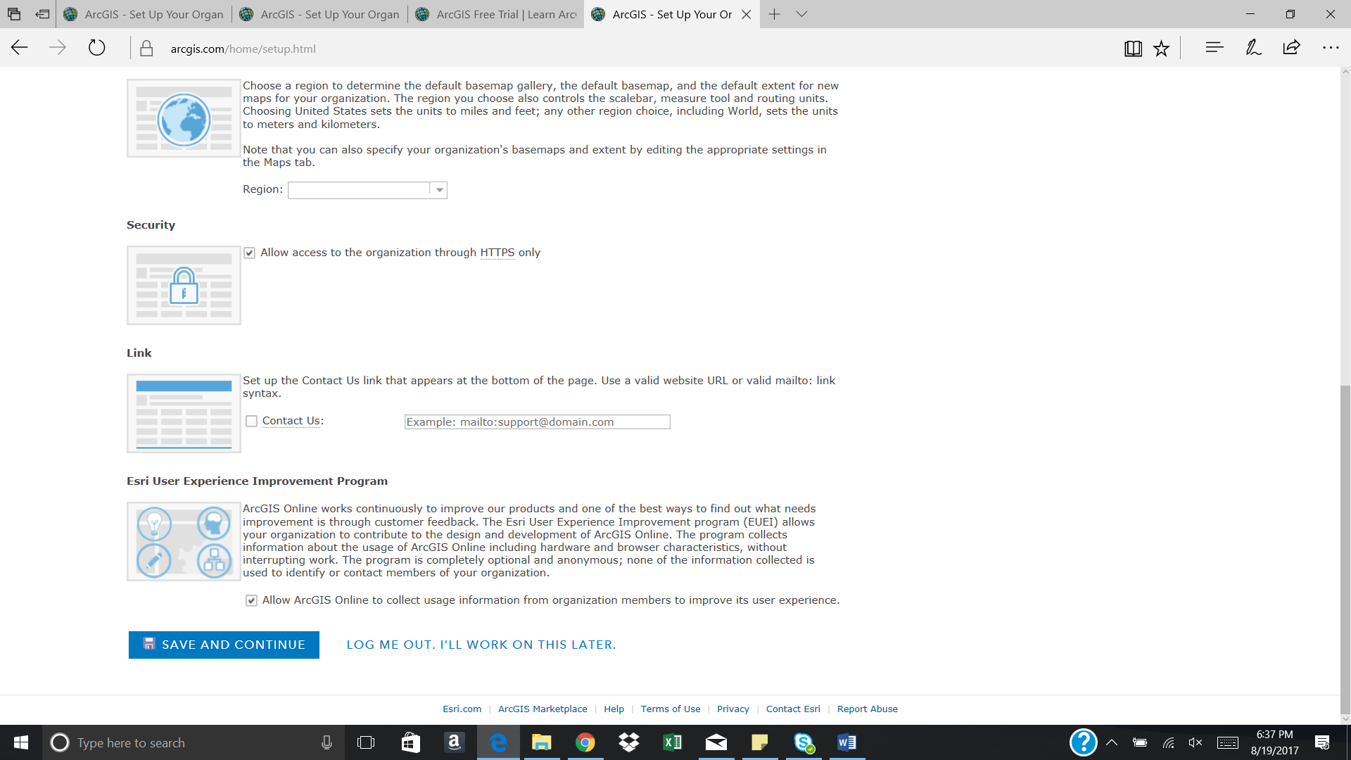

Then, Click on Save and Continue. If a popup appears, Select Continue with ArcGIS Online.

Under Organization -> go to Manage Licenses

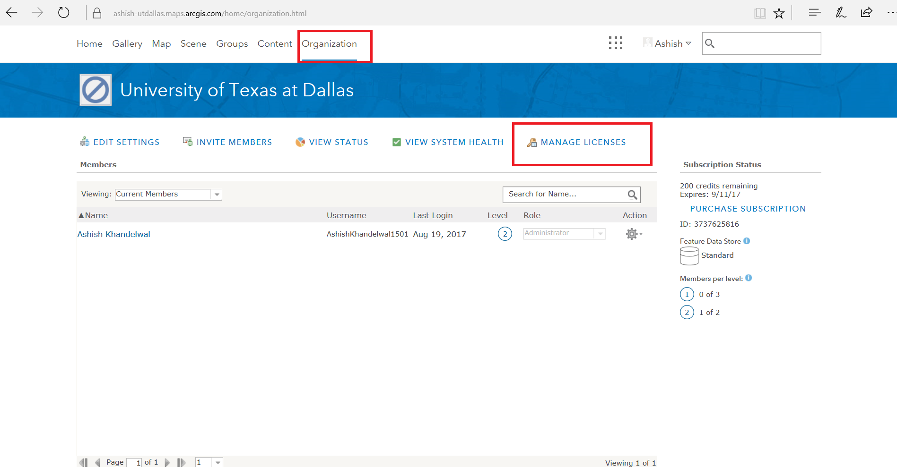

Then click on your name. It will get added to selected members

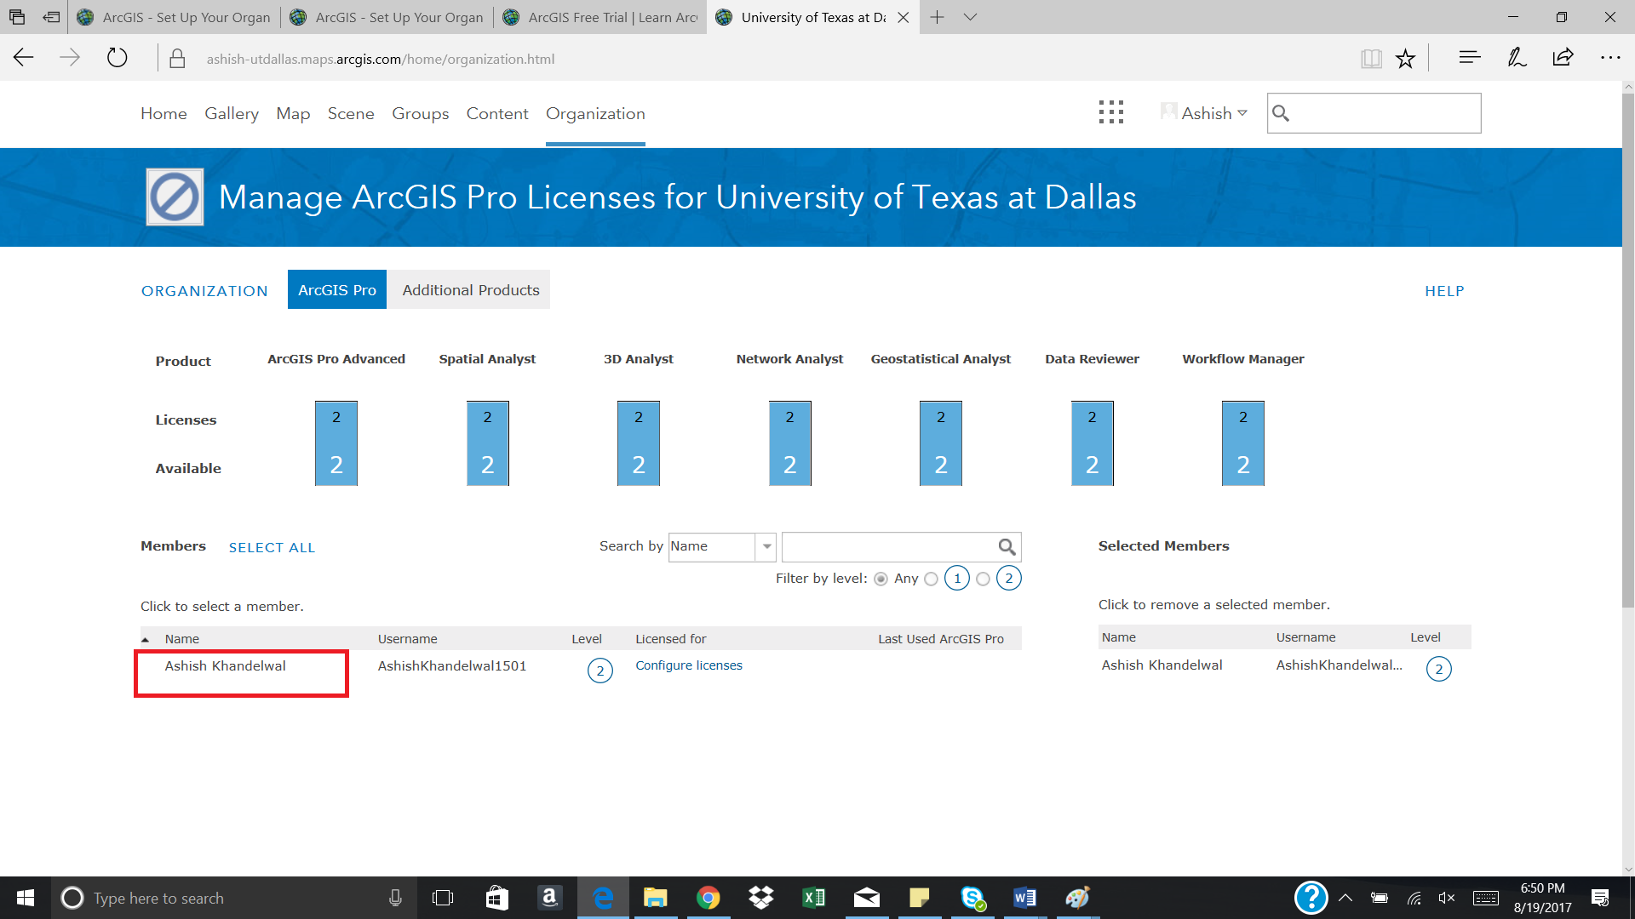

Now Click on Configure Licenses.

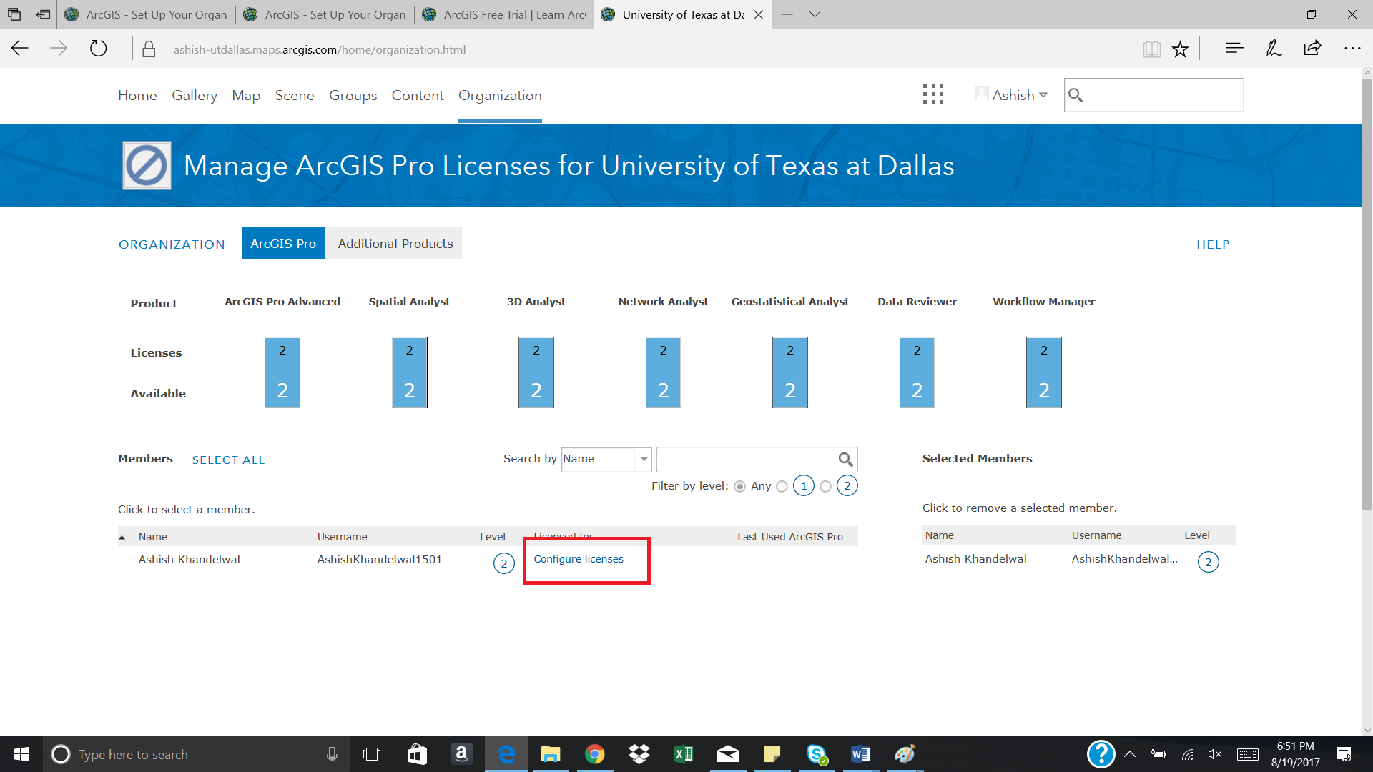

Check All the boxes under the extensions as shown below and click on Assign

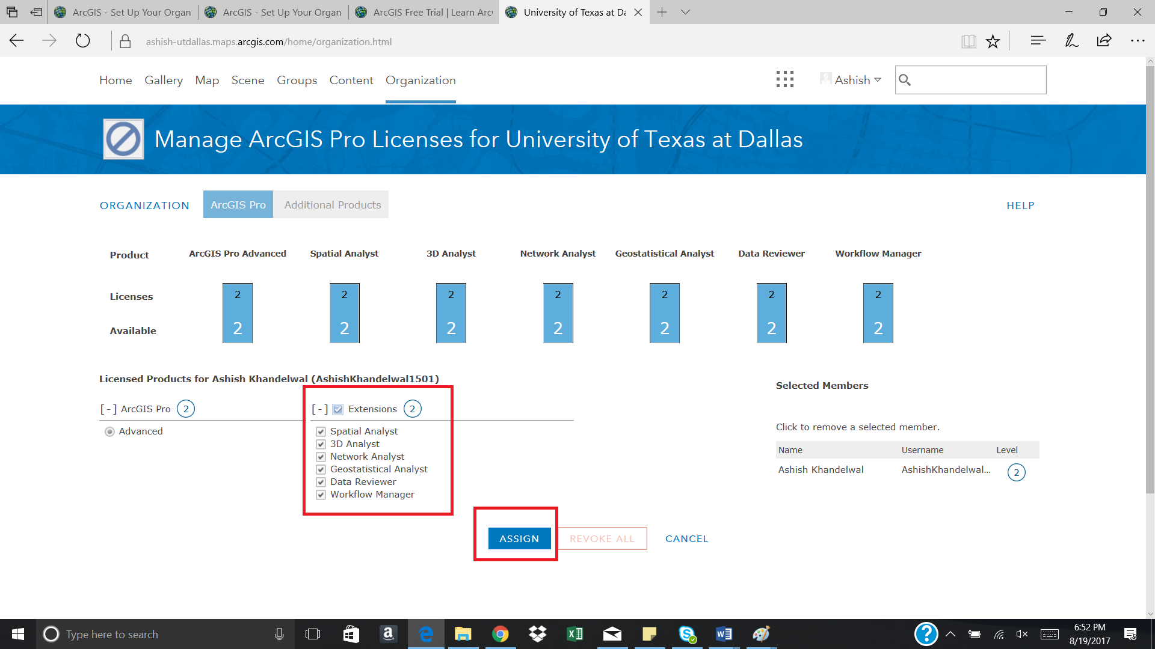

You will receive a successful configuration message. Click on OK

**Step 8**: **Find missing geocodes using ArcMap**

Under Organization -> goto Manage licenses and click on your name. It will get added to selected members

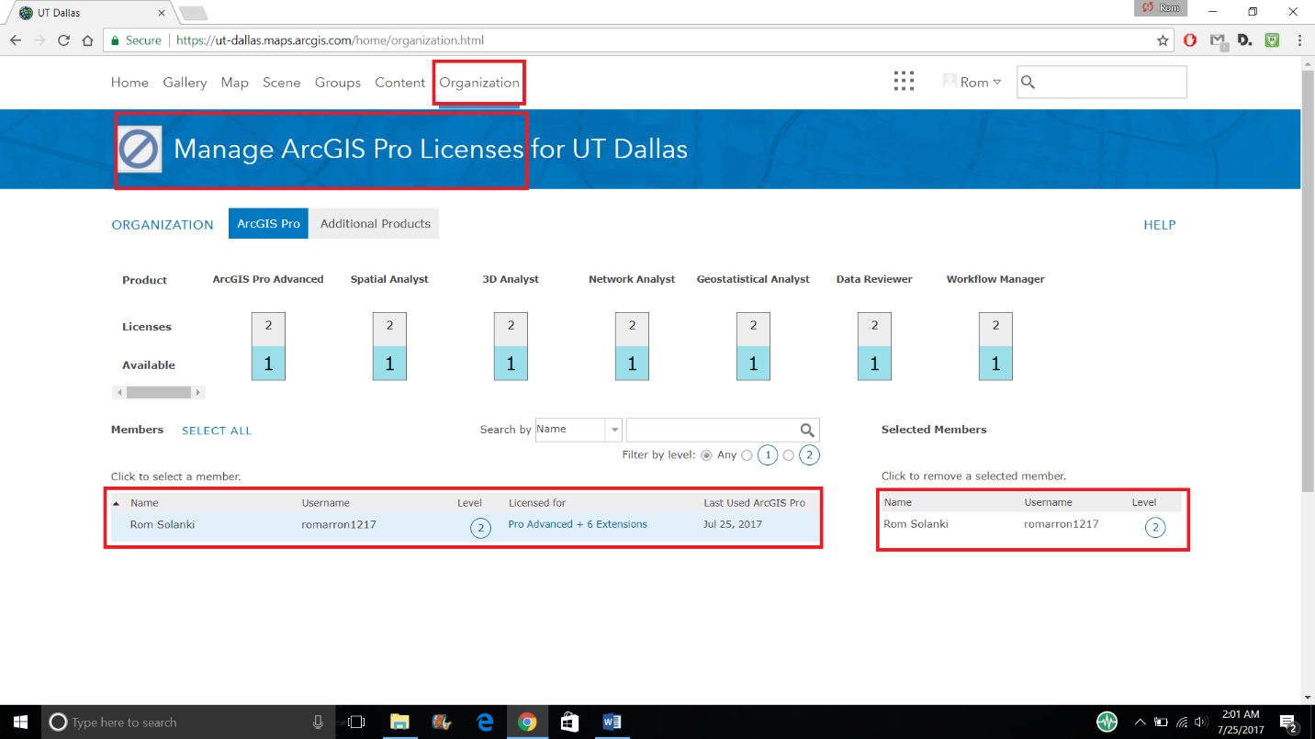

If there is a checklist of features, check them all.

Open ArcGIS Desktop application. Sign-in with your credentials and create a new blank project.

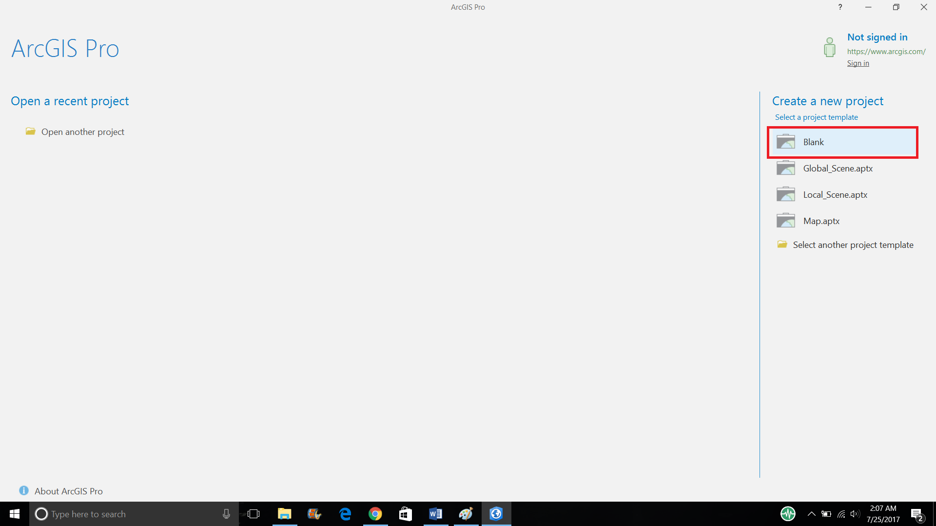

Click on New Map -> New Map.

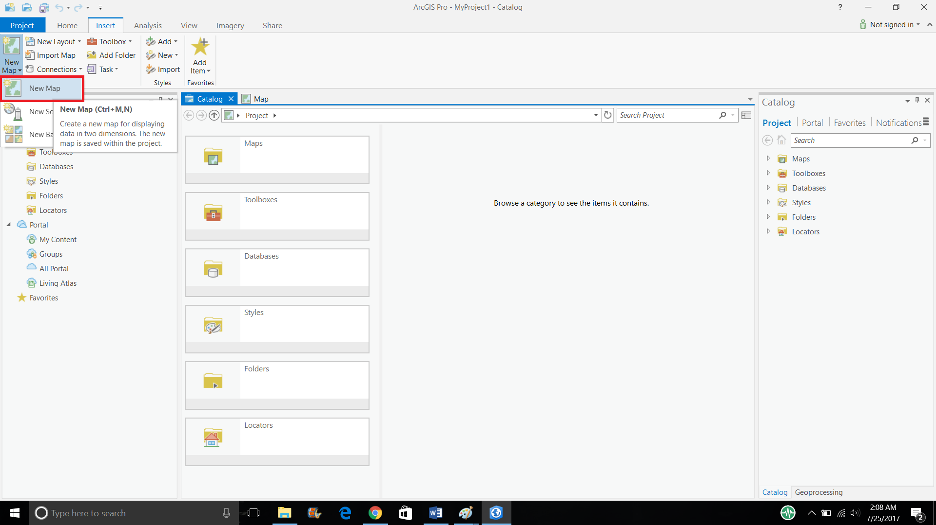

Then click on Add Data and insert the CSV file saved in the previous step.

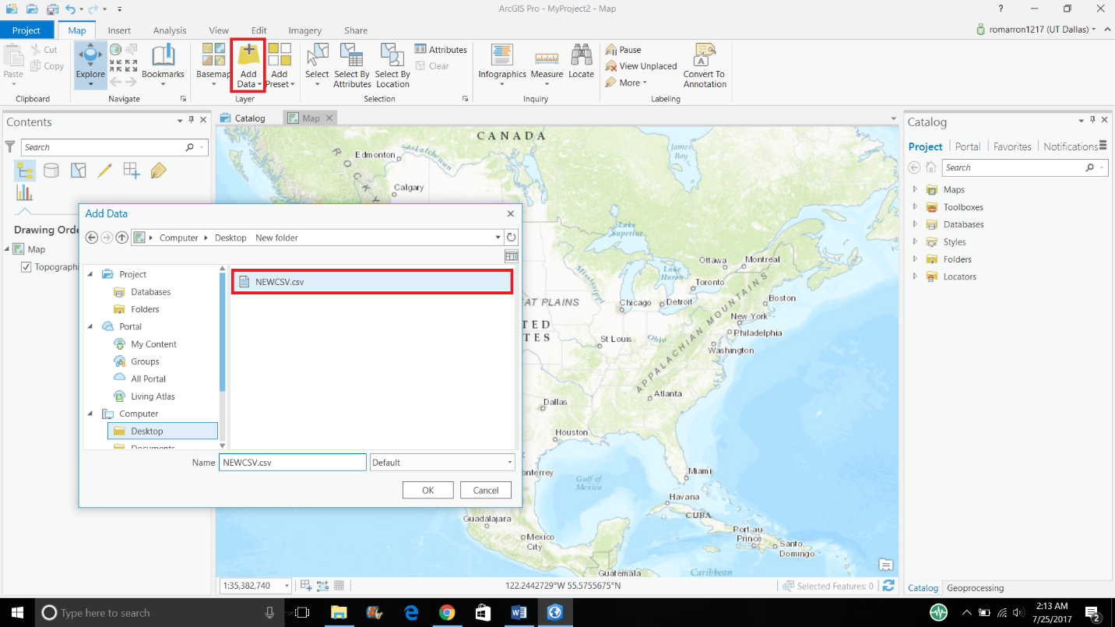

Right click on your datasource and select Geocode Table.

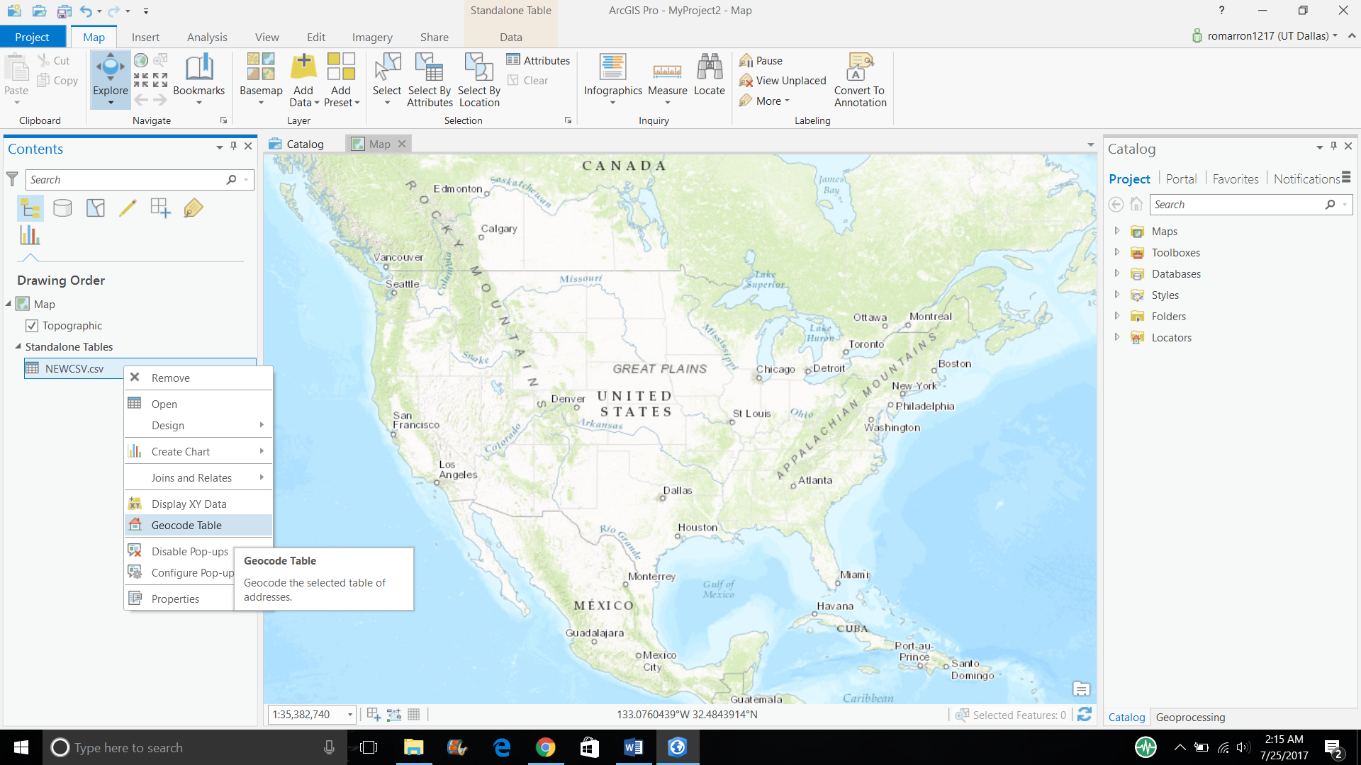

Select following parameters from dropdown.

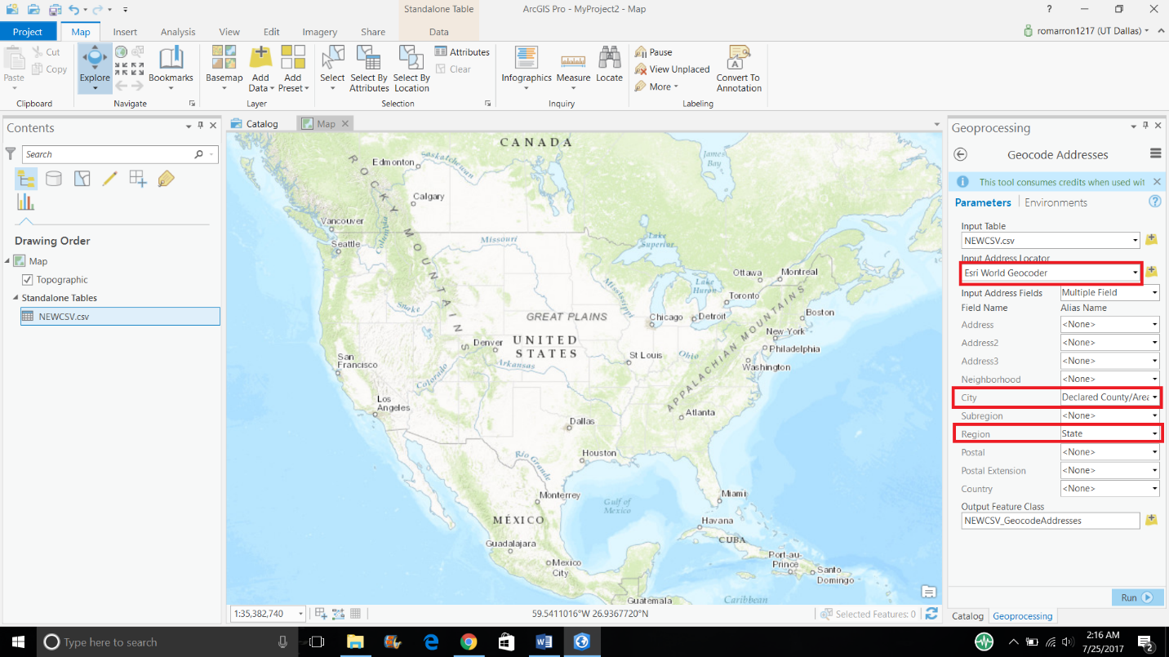

Then click on run at the bottom right of the parameter section. You will get following window:

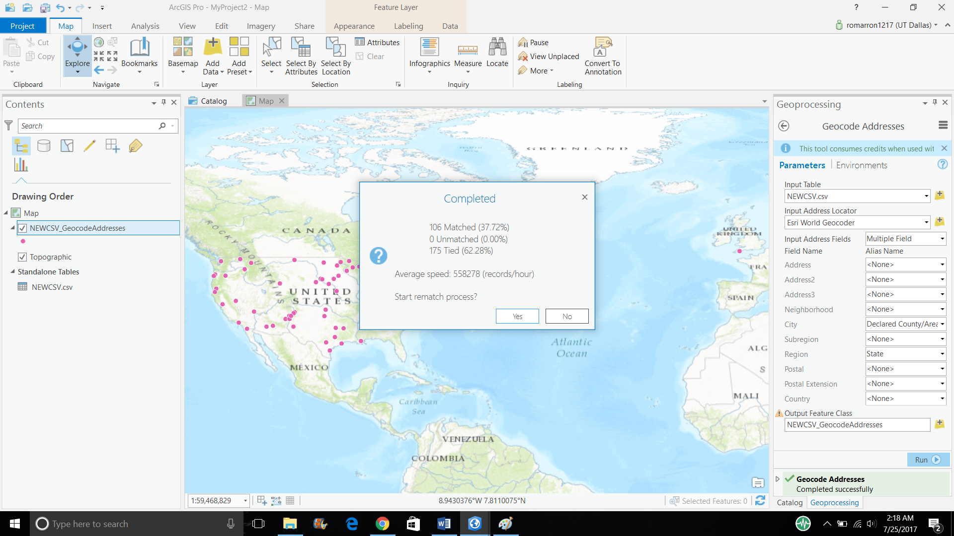

Click NO.

Then right click on the newly created table with geocodes and select attribute table.

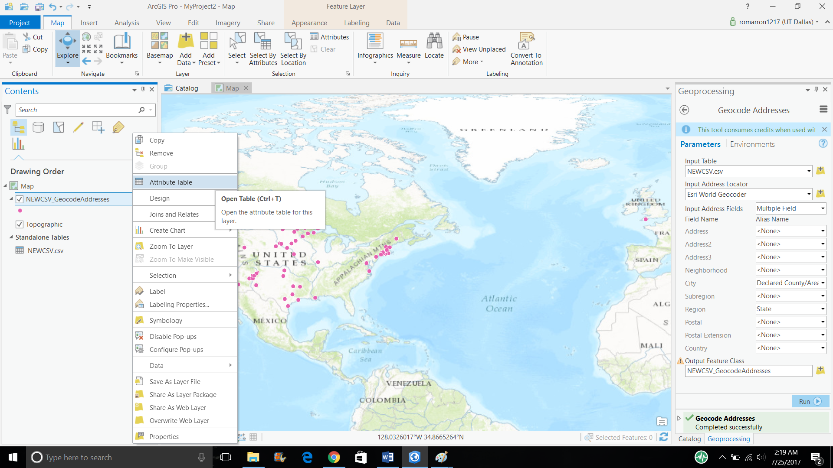

Select Fields View from the top right menu button.

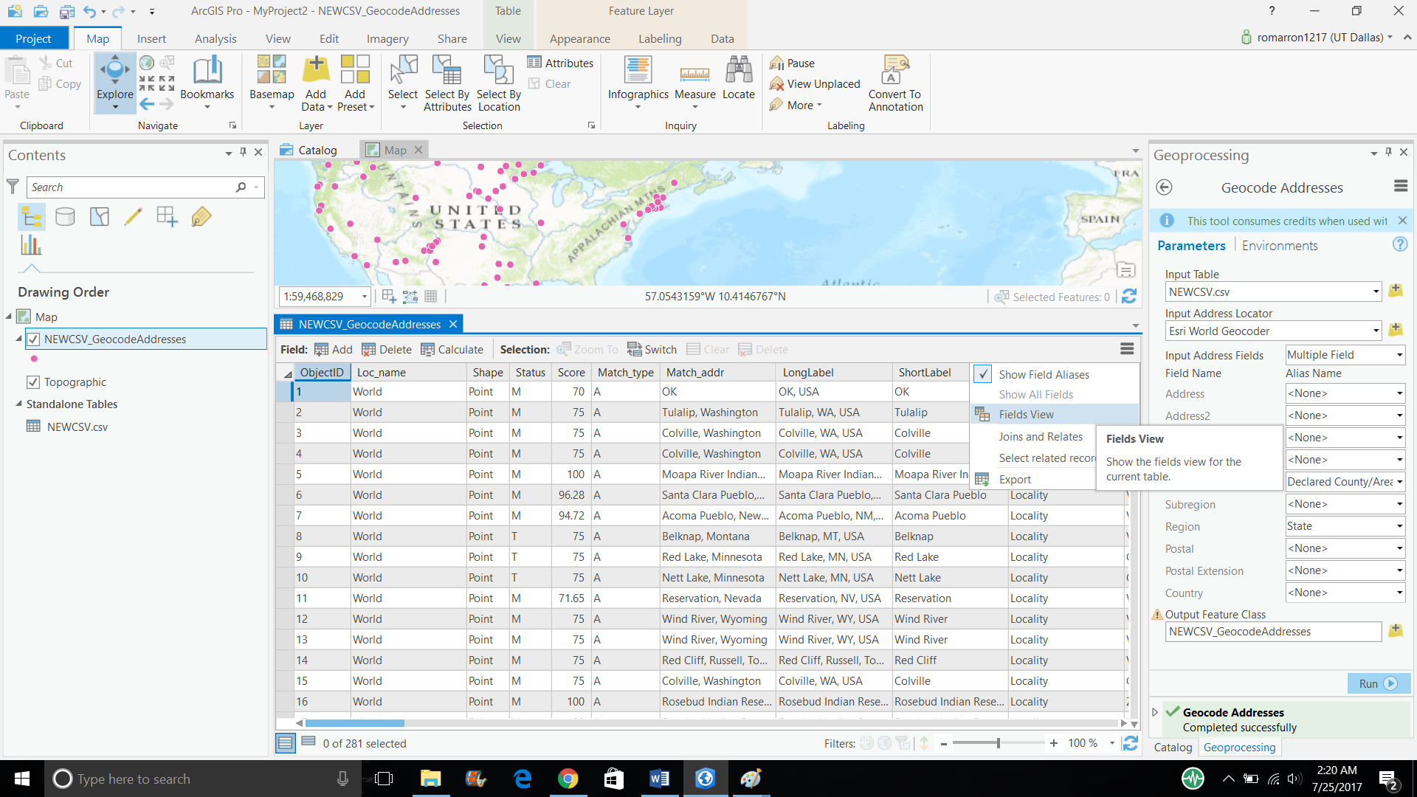

Deselect visibility all the fields except X,Y, USER_Declared_County_area and USER_State.

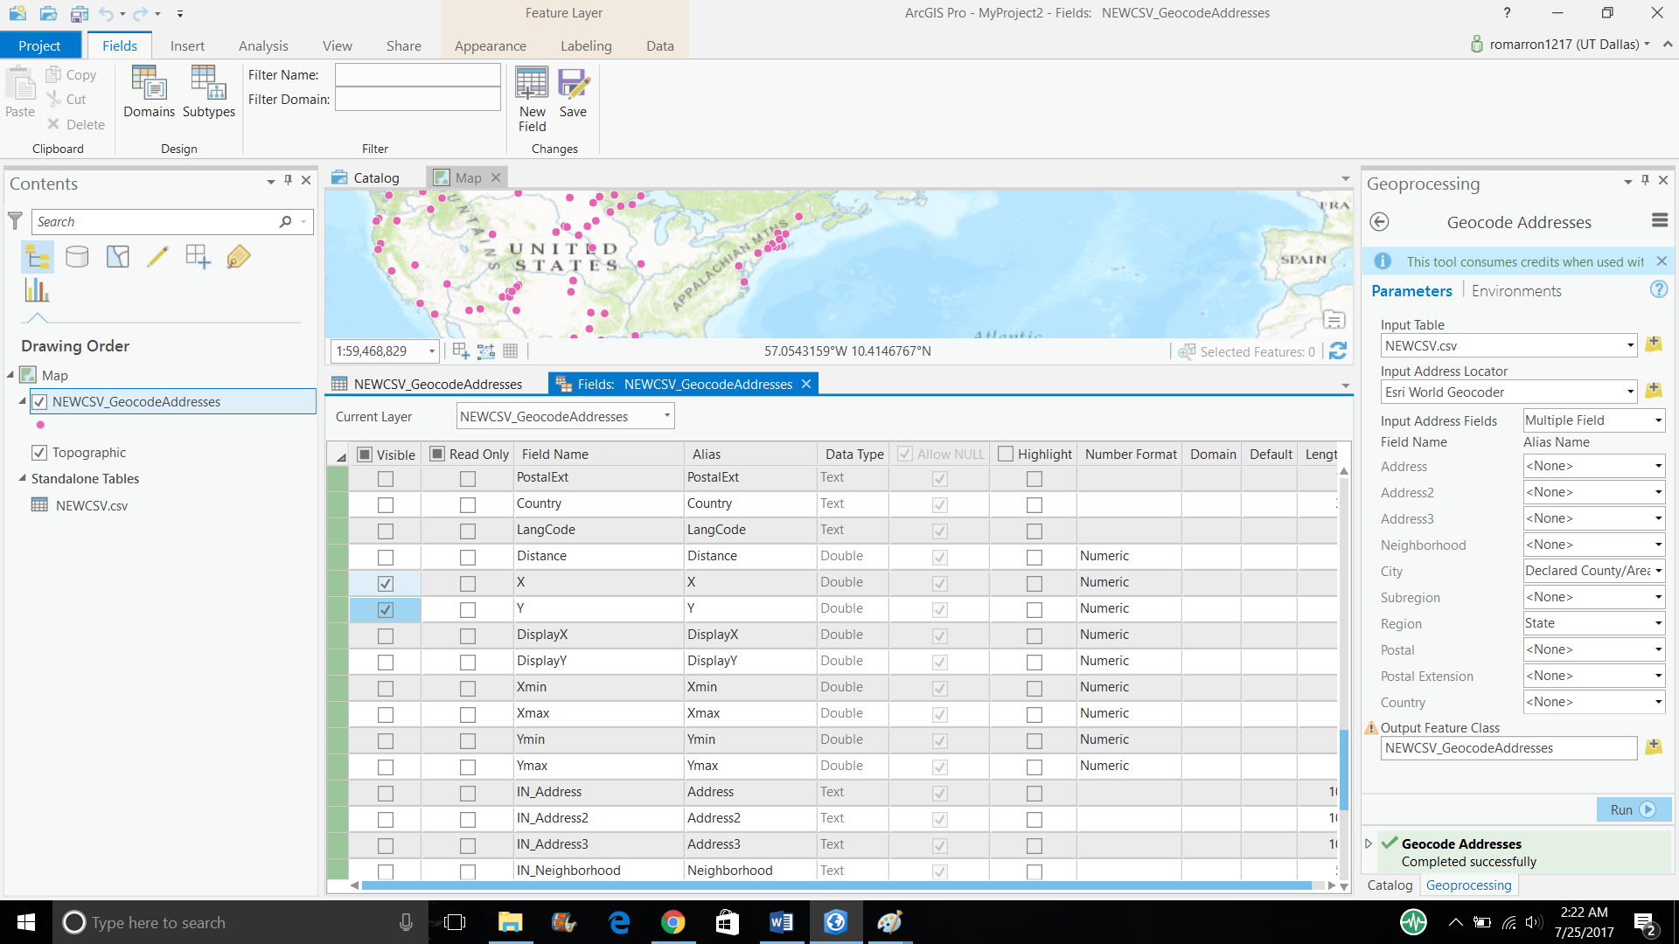

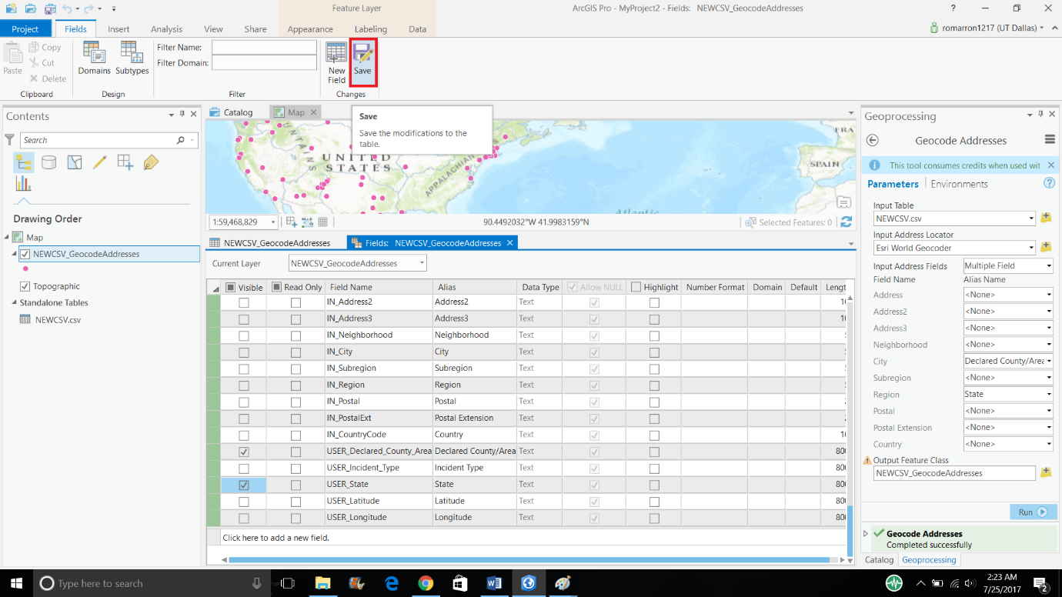

Then click on save.

Go back to attribute table and select export from top right menu button.

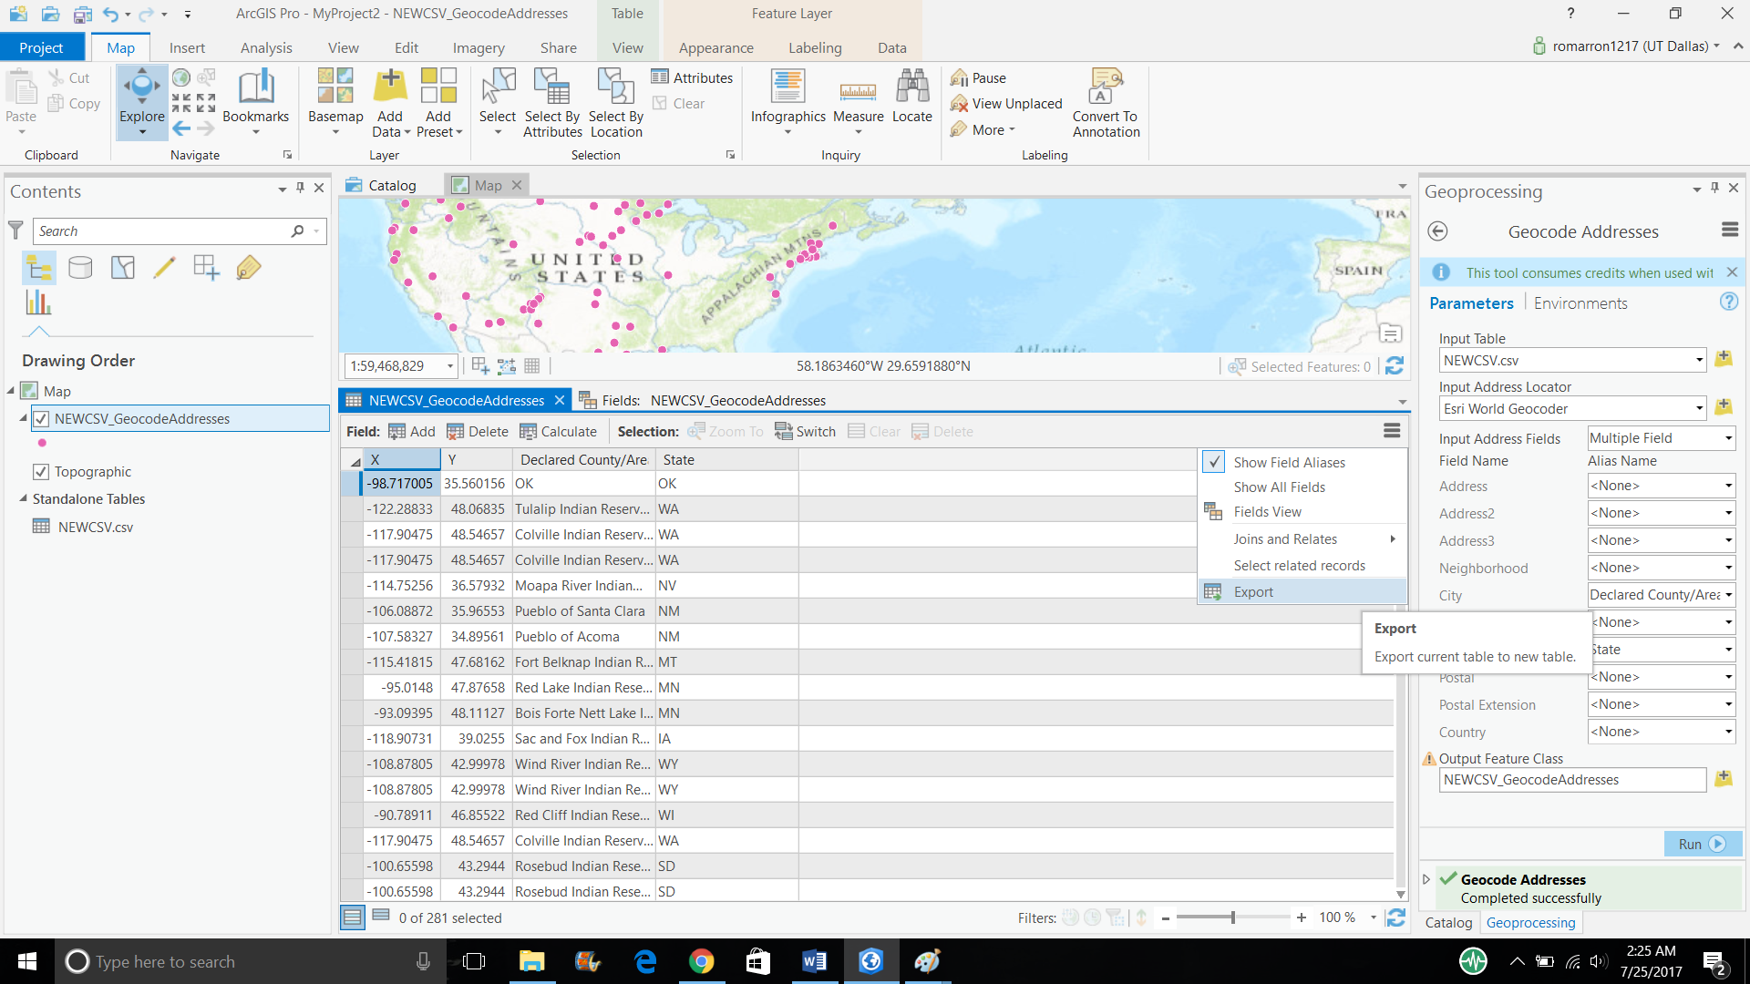

Click on browse button, save the new file on the desktop with the extension “.dbf”.

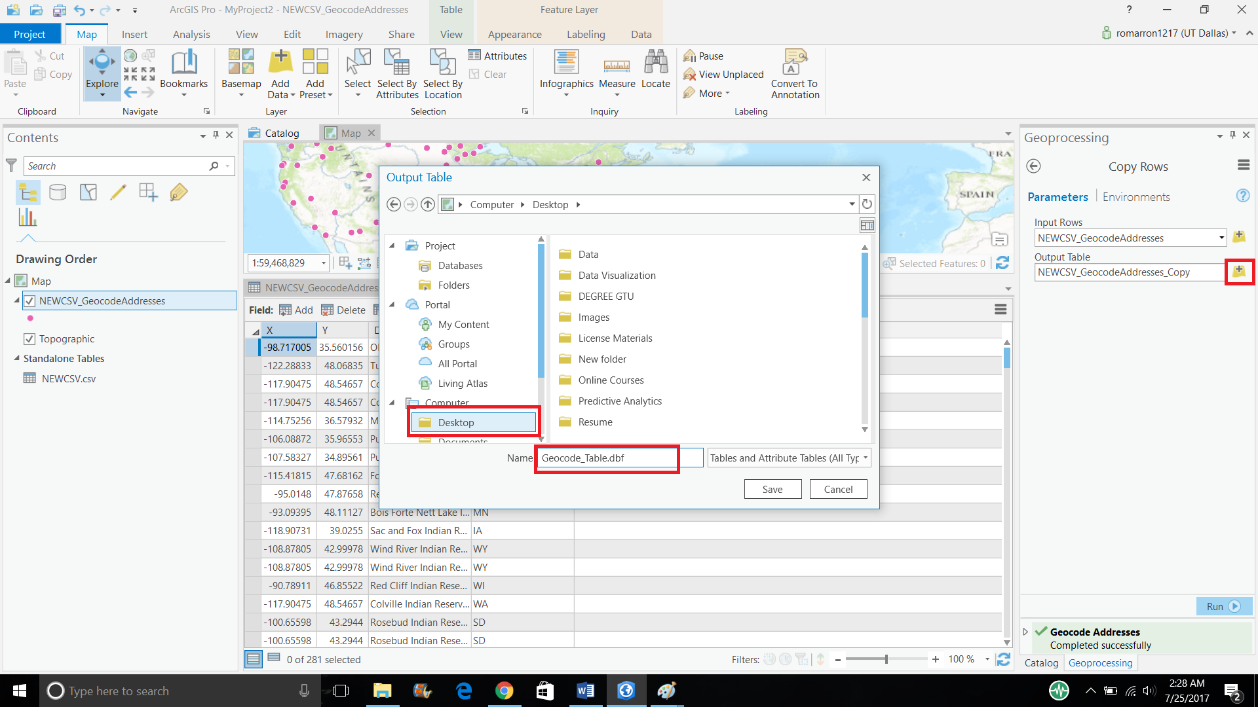

* To open downloaded file open a blank excel sheet and click on open button, navigate to the location (Desktop) where you saved the file and open file with type .dbf (select ‘All Files’ if you cannot find .dbf file)

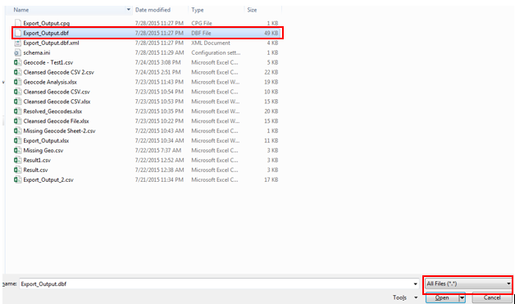

Make following changes in excel:

* To view data properly change width of the column Declared_C and State, make it 25 and save this file as ‘Geocode Output.xlsx’ file

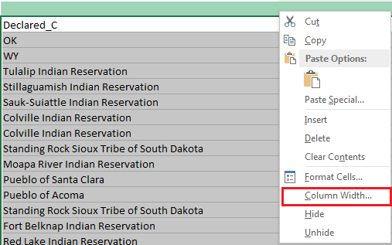

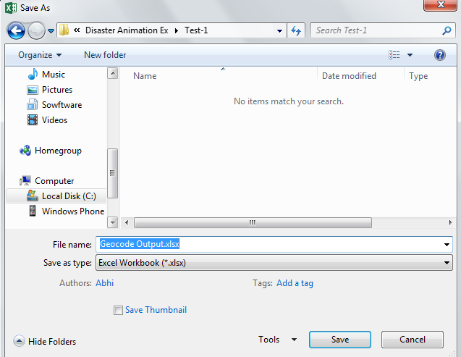

* Rename column X to longitude
* Rename column Y to latitude
* Filter excel data where Latitude Longitude are equal to 0
* There must be few counties for which geocodes are still missing and you need to find geocodes of these counties on your own

**Hint**: Run searches, check Wikipedia

**Caution**: Be diligent while filling latitude longitude column, make sure you are filling latitude in latitude column and longitude in longitude column also if there is a minus sign with latitude or longitude then please maintain the sign as well.

* Once you get the missing geocodes update the Geocode Output.xlsx file with these geocodes

**Question:**

1. **Paste the screen shot of those counties for which you have found latitude longitude manually. Your screen shot should show County, State, latitude, longitude.**

**Answer**

* After completing this step your Geocode Output.xlsx file should contain latitude longitude of all the counties and states

Step 9: Update ‘Excel-1 Natural Disasters.xlsx’

* You have geocodes in file Geocode Output.xlsx that are missing in ‘Excel-1 Natural Disasters.xlsx’ so now you need to update these geocodes in ‘Excel-1 Natural Disasters.xlsx’ file which you had downloaded in Step-1, here are few hints to expedite this process:
  + In file ‘Excel-1 Natural Disasters.xlsx’ apply filter on latitude longitude with value 0 (blank)
  + Sort County and State column (A to Z)
  + In file Geocode Output.xlsx sort County and State same as above
  + Now check first record in Geocode Output.xlsx, copy latitude longitude, find same record in Excel-1 Natural Disasters.xlsx and copy latitude longitude in corresponding fields, repeat same process for all the geocodes

Step 10: Update Tableau Data Source

* After updating missing latitude and longitude in ‘Excel-1 Natural Disasters.xlsx’ go back to you Tableau sheet and remove ‘Longitude’ filter ( as soon as you will remove this filter all the disasters will reappear on the map and also the null value label )
* Since we have made changes in our data source (Excel-1 Natural Disasters.xlsx ) we need to refresh our dataset in Tableau so that it can plot the updated geocodes. To refresh data source click on Menu option ‘Data’ hover over your data source name and click on ‘Refresh’ and after clicking on ‘Refresh’ the null label should get disappear, this means Tableau has pulled the updated and in updated data source there are no missing geocodes.

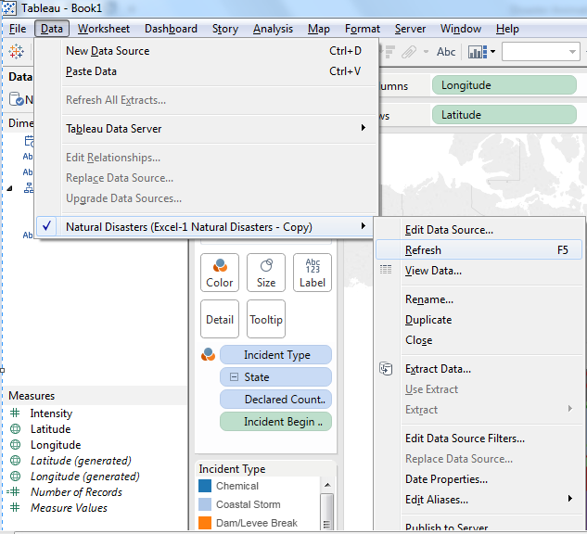

**Question:**

1. Paste the screen shot of your Tableau sheet

**Answer**

**Part 2: Animate Disasters on Map**

Step 1: Create Refinery and Disaster group

* Although we have geocode data of refinery locations in our data source however it is difficult to find refinery locations on the map. To overcome this challenge we will create a group of refineries and disasters so that disasters and refineries geocodes can be encoded distinctly, follow below steps to create a group:
  + Right click on ‘Refinery’ field and under ‘Create’ select group

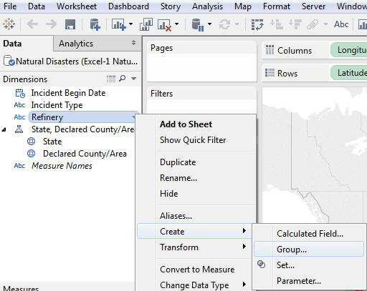

* + Rename this group as ‘Refinery & Disaster’, select all the refineries and click on ‘Group’ button and name it ‘Refineries’ and click ok (check screen shot)

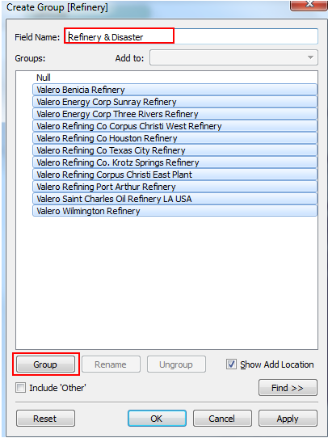

* + Right click on newly created group and select ‘Aliases’. In the pop-up alias ‘Null’ to ‘Disaster’ and click ‘ok’ (check screen shot)

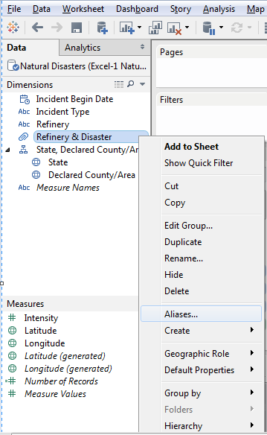

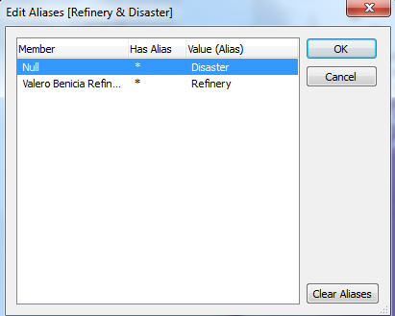

Step 2: Remove fields from the shelf

* Except ‘Incident Type’ remove all the other fields from the shelf

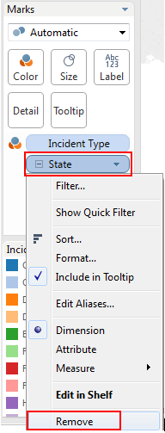

Step 3: Filter data based on Year

* Drag and drop ‘Incident Begin Date’ to filter pane, once you drop ‘Incident Begin Date’ to filter pane you will get a pop-up, select ‘Year’ in that pop-up and select **‘Null’** and a year value (you can select any year however to see Hurricane track please select any year between 2004 to 2012)

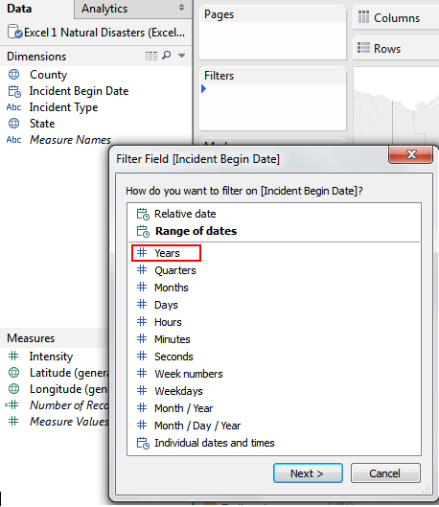

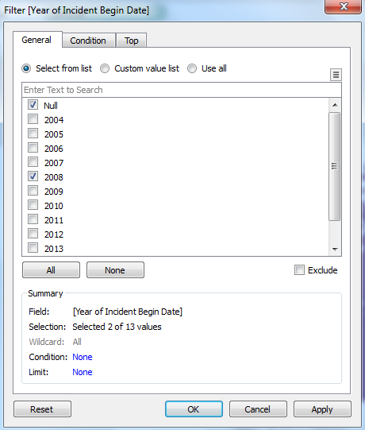

Step 4: Encode Refineries and Disasters

* To distinguish refineries from disasters we will encode disaster geocodes and refinery geocodes distinctly
  + In ‘Marks’ shelf click on drop down and select shape

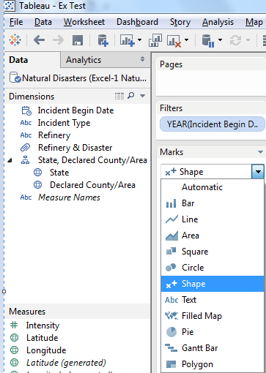

* + Drag and drop ‘Refinery & Disaster’ group to shape card
  + To change the shape of refineries and disasters double click on ‘Disaster’ under ‘Refinery & Disaster’ pane and change the shape as per below screen shot

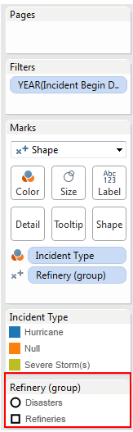

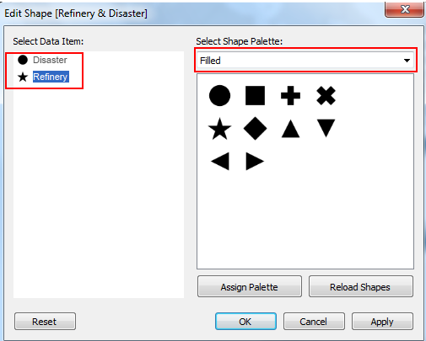

* + Drag ‘Intensity’ field to ‘Size’ card and change the color of disasters, refineries as per your choice

**Question:**

1. **Paste the screen shot of your Tableau sheet**

**Answer**

Step 5: Animate Disasters:

* Drag ‘Incident Begin Date’ to ‘Pages’ pane, by default Tableau will take ‘Year’ of incident date, to get exact incident date click on the arrow on ‘Year’ and select ‘Exact Date’:

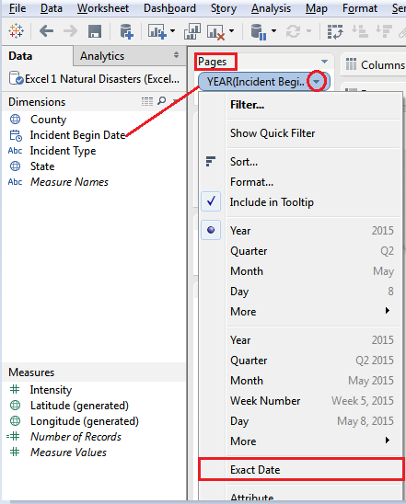

* After completing above step you will see animation play button and other options related to animation:

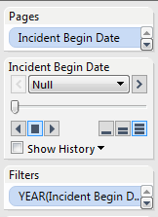

* To make our animation look better make following changes:

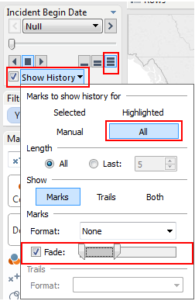

**Question:**

1. Add Incident Type and Incident Begin Year to label card (display Year and Month as label) and paste the screen shot of your ‘Marks’ pane.

**Answer**

1. Make changes in your Tool Tip, only ‘Incident Begin Date’ and ‘Incident Type’ should appear as tool tip. Click on tool tip card and paste the screen shot of pop-up.

**Answer**

After making above changes hit the play button and run the Disaster Animation

**Question:**

1. Run disaster simulation for year 2005 and list the refinery locations impacted by disasters

**Answer**

As a part of this exercise you need to submit following documents:

* This exercise document with only your answers
* Your Tableau file